23rd November 2022

SUMMONS TO ATTEND A MEETING OF
THE PLANNING SUB-COMMITTEE

TO: All Members of the Planning Sub-Committee

DATE: 29th November 2022

TIME: 2pm

LOCATION: The Council Chamber, Chipping Norton Town Hall

Luci Ashbourne
Town Clerk

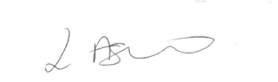
Recording of Meetings
Under the openness of Local Government Bodies Regulations 2014 the council’s meetings may be recorded, which includes filming, audio-recording as well as photography.

AGENDA

- Apologies for absence.
To receive apologies for absence.
Committee members who are unable to attend the meeting should notify the Town Clerk (townclerk@chippingnorton-tc.gov.uk) prior to the meeting, stating the reason for absence.

- Declarations of Interest.
Members are reminded to declare any disclosable pecuniary interests in any of the items under consideration at this meeting in accordance with the Town Council’s code of conduct.

- Minutes.
To approve the Minutes of the Planning Sub-Committee meeting held on 8th November 2022.

- Public Participation
The meeting will adjourn for this item.
Members of the public may speak for a maximum of five minutes each during the period of public participation.
- Applications for consideration and planning appeals.
To receive and consider a schedule of planning applications.

